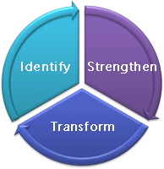
Equipping Minds
Cognitive Development Curriculum

A day by day curriculum designed for cognitive development including working memory, visual processing, auditory processing, attention, logic, comprehension, and more.
Cognitive development exercises with increasingly difficult levels. Classroom connection activities, instructional methods, and study skills included. This book is designed for use in the regular or special education classroom, clinic, or home environment.
Dr. Carol T. Brown, Ed.D Equipping Minds

